**Compilation**

jamess-imac:program AcousticTime$ g++ -c FileCheck.cpp

jamess-imac:program AcousticTime$ g++ -c Input.cpp

jamess-imac:program AcousticTime$ g++ -c LinearRegression.cpp

jamess-imac:program AcousticTime$ g++ -c StringToFloat.cpp

jamess-imac:program AcousticTime$ g++ -o program4A program4A.cpp FileCheck.o Input.o LinearRegression.o StringToFloat.o

jamess-imac:program AcousticTime$

**Test 1**

jamess-imac:program AcousticTime$ ./program6A

What would you like to do?

Enter 1 to read from file.

Enter 2 to write to file.

Enter 3 to modify a file.

Enter 4 to calculate linear regression and prediction interval.

Enter 0 to quit.

Choice: 4

Enter the x-axis values filename: xvalues

Enter the y-axis values filename: yvalues

Enter the estimated object LOC to use: 386

B0 = -22.5524

B1 = 1.72793

Range 70% = 229.972

UPI 70% = 874.401

LPI 70% = 414.458

Range 90% = 386.053

UPI 90% = 1030.48

LPI 90% = 258.376

Prediction for 386 = 644.429

jamess-imac:program AcousticTime$

**Test 2**

jamess-imac:program AcousticTime$ ./program6A

What would you like to do?

Enter 1 to read from file.

Enter 2 to write to file.

Enter 3 to modify a file.

Enter 4 to calculate linear regression and prediction interval.

Enter 0 to quit.

Choice: 4

Enter the x-axis values filename: x

Enter the y-axis values filename: y

Enter the estimated object LOC to use: 2

B0 = 151.055

B1 = -0.279586

Range 70% = 82.6983

UPI 70% = 233.194

LPI 70% = 67.7976

Range 90% = 138.826

UPI 90% = 289.322

LPI 90% = 11.6703

Prediction for 2 = 150.496

**Test 3**

jamess-imac:program AcousticTime$ ./program6A

What would you like to do?

Enter 1 to read from file.

Enter 2 to write to file.

Enter 3 to modify a file.

Enter 4 to calculate linear regression and prediction interval.

Enter 0 to quit.

Choice: 4

Enter the x-axis values filename: x

Enter the y-axis values filename: y2

Enter the estimated object LOC to use: 2

B0 = 100.656

B1 = 0.024859

Range 70% = 28.445

UPI 70% = 129.15

LPI 70% = 72.2603

Range 90% = 47.7507

UPI 90% = 148.456

LPI 90% = 52.9547

Prediction for 2 = 100.705

**UML Class Diagram**

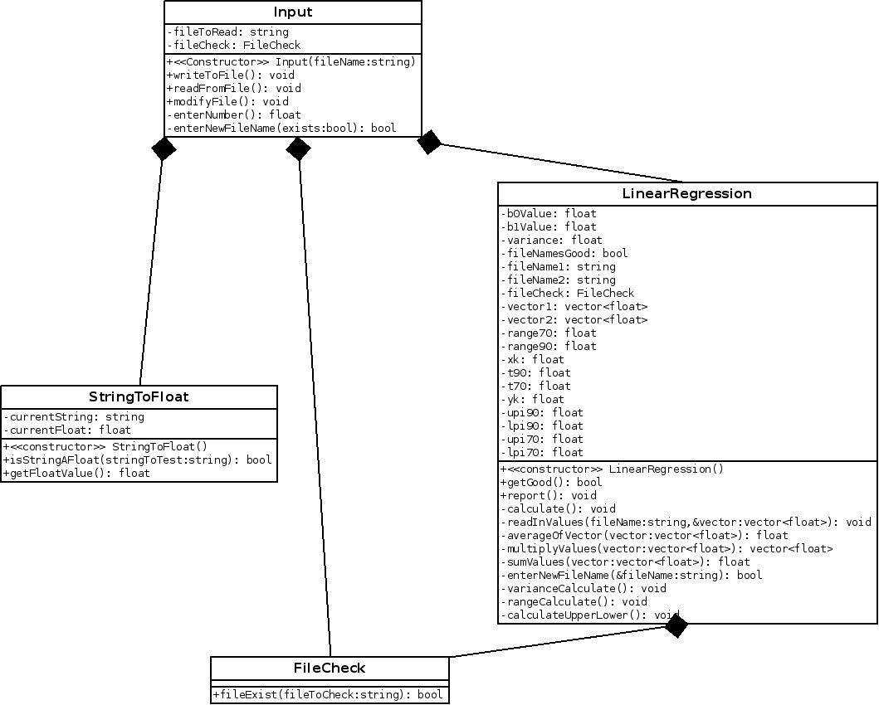

**UML Use Case Diagram**

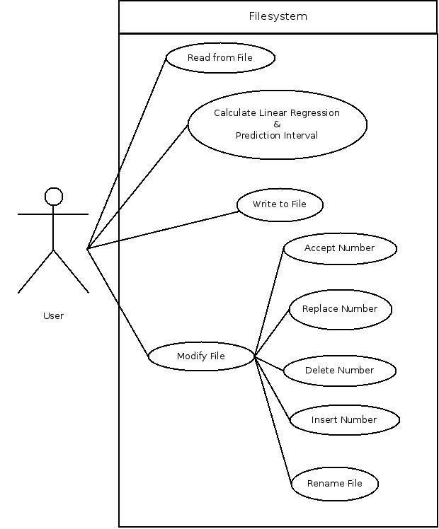

|  |  |  |  |
| --- | --- | --- | --- |
| **Test** | **Parameter** | **Expected Value** | **Actual Value** |
| 1 | B0 | -22.55 | -22.5524 |
|  | B1 | 1.7279 | 1.72793 |
|  | UPI 70% | 874 | 874.401 |
|  | LPI 70% | 414 | 414.458 |
|  | UPI 90% | 1030 | 1030.48 |
|  | LPI 90% | 258 | 258.376 |
| 2 | Estimated New and Changed LOC |  | 150.496 |
|  | UPI 70% |  | 233.194 |
|  | LPI 70% |  | 67.7976 |
|  | UPI 90% |  | 289.322 |
|  | LPI 90% |  | 11.6703 |
|  | Actual New and Changed LOC |  | 78 |
| 3 | Estimated New and Changed LOC |  | 150.496 |
|  | UPI 70% |  | 129.15 |
|  | LPI 70% |  | 72.2603 |
|  | UPI 90% |  | 148.456 |
|  | LPI 90% |  | 52.9597 |
|  | Actual Time |  | 121 |